***Rosanna Scout Group***



***2017 Christmas Breakup***

On **Wednesday**, **December the 6th,** we will hold our eleventh Annual Group Christmas Breakup.

This will be held at **Rosanna Bowling Club** – Barefoot bowling - and all Cubs, Scouts, Venturers and Rovers from our Group – *and* their families – are invited!

**PLEASE NOTE** that this is a family night. It is not expected that parents would drop Cubs, Scouts or Venturers at the Hall without prior arrangement.

**Details:**

* Location: Rosanna Bowling Club – Strasbourg Rd
* Date/Time **7pm, Wednesday, 6th December**
* **$2 per person** to cover costs.
* **Cub families**: Please bring a **Dessert** to share
* **Scout/Venturer/Rover families**: Please bring a **Salad** to share
* Those with children in ***more than one Section*** *(Scouts/Cubs/Venturers/Rovers)* please bring a **loaf of** **bread** **plus** **a Dessert**
* ***Please respond ASAP via email*** *with numbers attending (adults/children) and the food you’re bringing to share.... by the* ***30th*** *at the latest. We need to confirm numbers for catering and for the Bowling Club*
* We will supply meat BBQ, cordial, disposable crockery, cutlery and cups
* While there are some seats, bring folding chairs etc. if you like.
* **PLEASE** bring a ***present*** for each of your own kids (*including siblings* of Youth Members) max $15, wrapped AND **clearly named** as to who it’s for. A bag will be available for these to be (quietly) deposited into.
* ALL Youth Members and Leaders must be in Full Uniform.

If you have any queries, please call Wayne 0411 121 495.

Regards

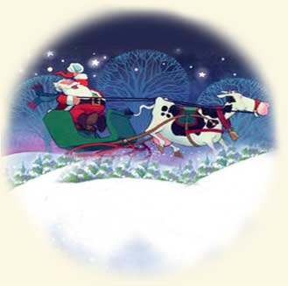

Wayne (Akela)

